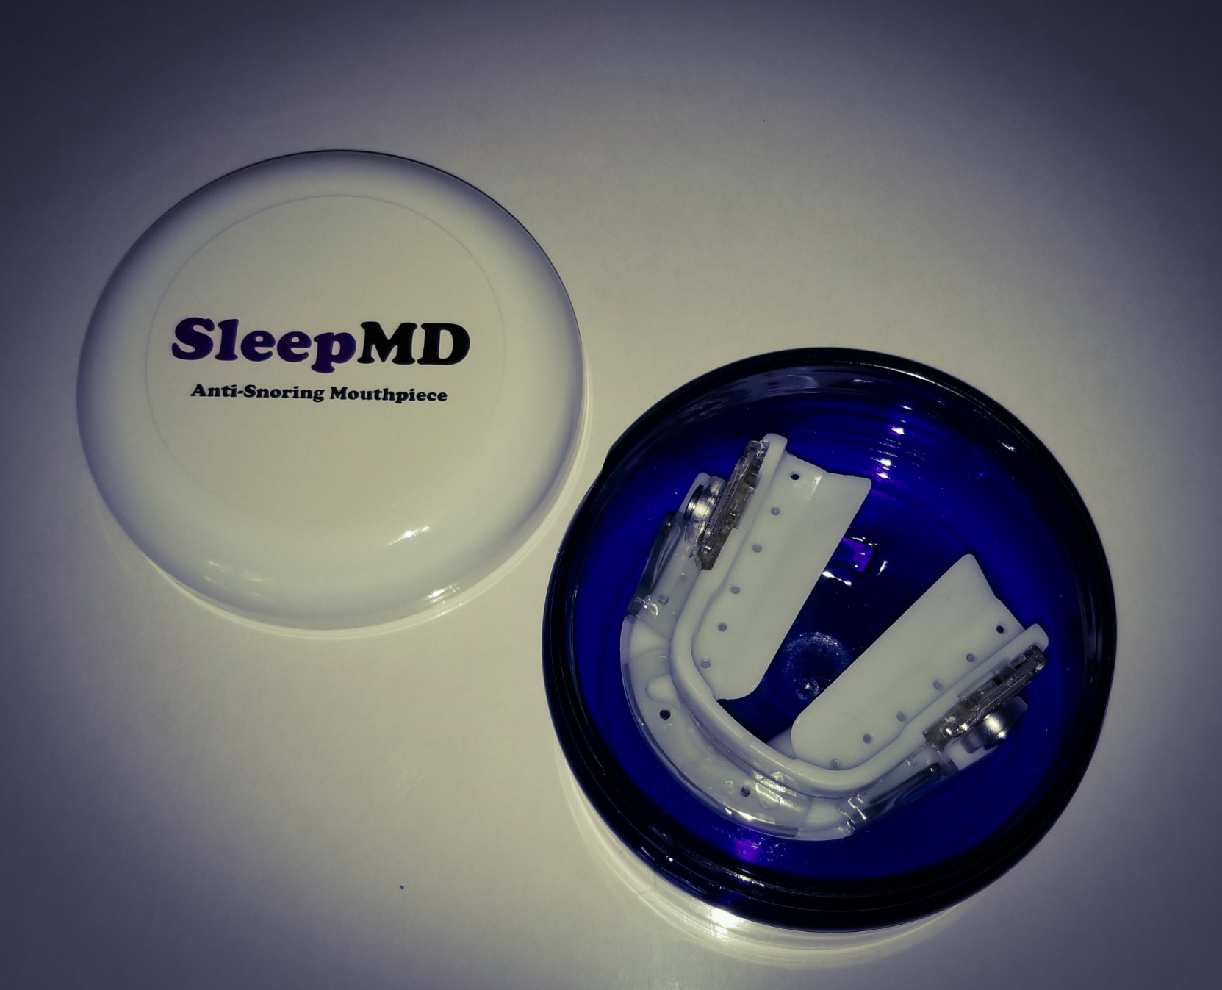

SleepMD mouthpiece
Maintenance of mouth movements:
The design incorporates the very successful “dorsal wing” design used in the most successful and sought after “prescription only” appliances on the market. This design allows the patient to talk, drink and mouth breath while maintaining a patent airway. Your teeth are never locked in position. They are guided by the interaction of the wing and the opposing cams.

Customization:
Customization is a key factor in all the appliances used in Dental Sleep Medicine. This is because the shape of our mouth varies from one to another. To be successful, an oral appliance needs to adapt to multiple shapes and sizes. SleepMD uses a dual laminate plastic design that molds to the teeth regardless of such variations. The included plastic beads used during the molding process insures the retention of the appliance.
Adjustability:
Successful treatment of snoring and obstructive sleep apnea requires the ability fine tune the amount of jaw advancement. Often, the patient may not initially tolerate the required position needed to maintain an open the airway. However, with time our jaw muscles will relax, and further advancement can be obtained. SleepMD provides a positioning system that allows 10 mm advances, 1 mm at a time. If more is needed, then you just need to remold at that position, while still maintaining the micro adjustments.

Clinically Validated:
The SleepMD mouthpiece has bee used in my Sleep Medicine practice for several years. It’s design and functional mechanism was borrowed from my earlier design, Nusleep Oral Appliance. This mouthpiece was available for almost 10 years and successfully treated over 4000 patients. The new SleepMD device has been vigorous testing in my sleep lab. Home sleep testing and Polysomnography has validated its successful treatment of this condition.

Materials:
All materials used in this device are FDA cleared and safe to use.

Dental Lab Not Required:
The molding process is done directly on the teeth. Impressions, dental models and lab fees are not needed.

